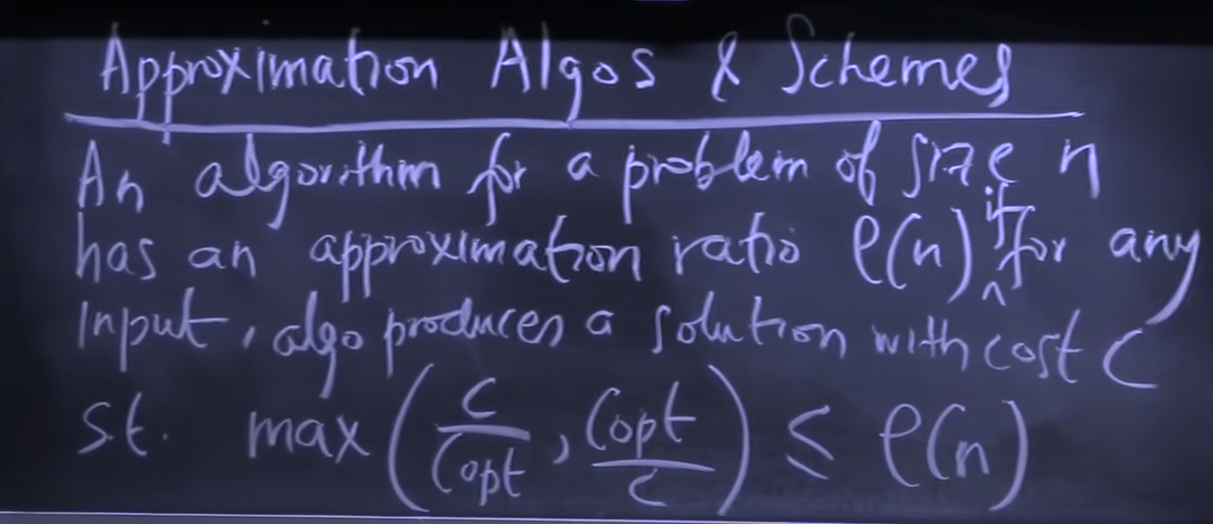

If the problem is of maximizing type

Then our answer will be less than the optimal solution. If our answer is greater than the optimal solution, then the optimal solution will not be optimal which contradicts the fact.

Hence in maximizing case (C/Copt) <= r

In minimizing case (Copt/C) <= r